Docker Final Task

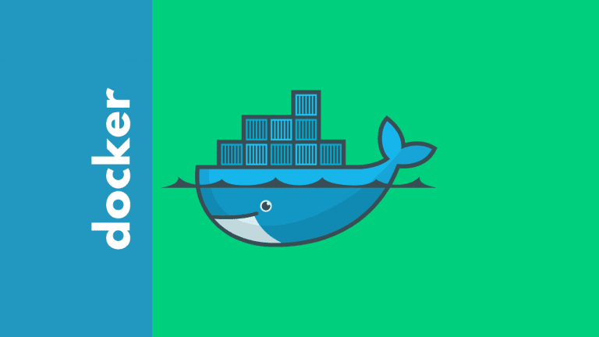

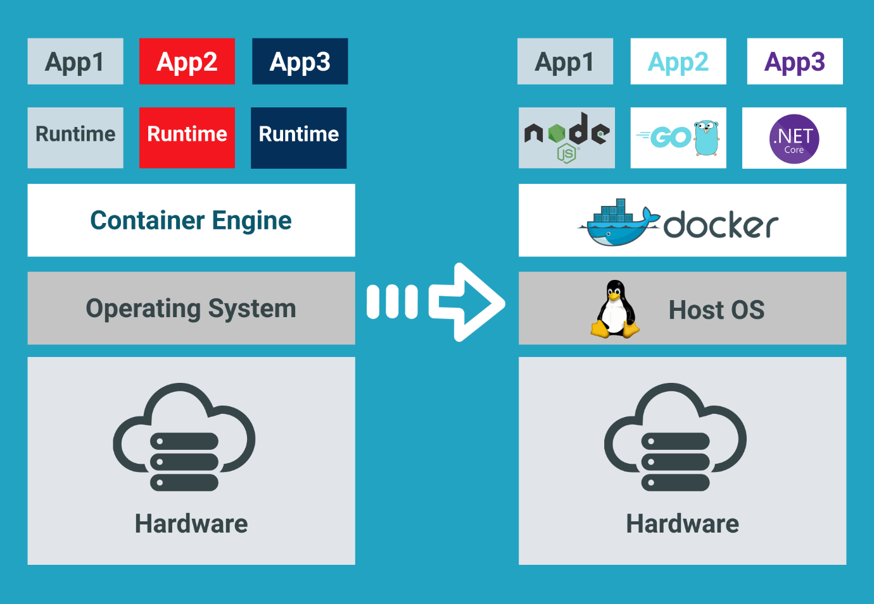

Task Title
Docker Final Task
Objective
The objective of this task is to execute the Docker Final Task posted on slack and worked on executing them as per requirement.
Prerequisites
Prerequisites for the Microservice Deployment:
We are preparing to deploy on Amazon Web Services using Terraform and Docker.
1) Tools Required on our Laptop
These must be installed locally.

- Docker Desktop
Needed to:
✔ build images
✔ tag images
✔ push to registry
docker --version

- AWS CLI
Used to:
✔ authenticate
✔ login to registry
✔ verify resources
Aws --version

- Terraform
Used to create infrastructure.
terraform version

2) Cloud Requirements

AWS Account
- Free tier or trial.
- Permissions to create:
  - VPC
  - EC2
  - Load Balancer
  - ECR
  - IAM
IAM User with Access Keys
Terraform and CLI must authenticate.
You need:
AWS_ACCESS_KEY_ID
AWS_SECRET_ACCESS_KEY

aws configure

3) Credentials & Permissions
User must be able to:
✔ create registry
✔ push images
✔ create compute
✔ create networking
✔ create security groups

4) Application Files
Inside project:
Dockerfile
index.html
Without this → no image.

5) Your Public IP Address
Needed for SSH restriction.
Get via:
curl ifconfig.me

6) Verify Before Starting (Checklist)
Before running Terraform ensure:
☑ docker working
☑ terraform working
☑ aws cli authenticated
☑ you can login to AWS
☑ region selected
☑ key pair ready

Simple Way to Remember
Laptop must be ready to:
- Build
- Tag
- push
Terraform must be ready to:
- create
- connect
- deploy

Issues Faced: Briefly mention issues and how you fixed them. Posted below in the last.
Conclusion
Conclusion has been provided for every task at the end.

Main Agenda of the Exercise
We are implementing a secure microservice deployment on Amazon Web Services using Infrastructure as Code with Terraform.
The application itself is simple (static webpage), so the focus is on:
- cloud architecture
- networking
- security
- automation
- container lifecycle

Objectives
By the end of this project, we should be able to:
- Containerize a web server using Docker
- Store the image in Amazon Elastic Container Registry
- Provision infrastructure automatically with Terraform
- Deploy container on Amazon EC2
- Expose the service only via Elastic Load Balancing
- Restrict direct public access to the VM
- Allow SSH only from trusted IP
- Follow Terraform best practices

Project Structure

microservice-terraform/
│
├── app/
│ ├── Dockerfile
│ └── index.html
│
├── terraform/
│ ├── main.tf
│ ├── variables.tf
│ ├── outputs.tf
│ ├── terraform.tfvars
│ ├── provider.tf
│ ├── networking.tf
│ ├── security.tf
│ ├── ecr.tf
│ ├── ec2.tf
│ └── alb.tf
│
└── scripts/
└── userdata.sh

Step by step Implementation
Step 1: From local machine, we have our Docker Desktop installed, so we shall access through our local cli
- Login to Docker Desktop
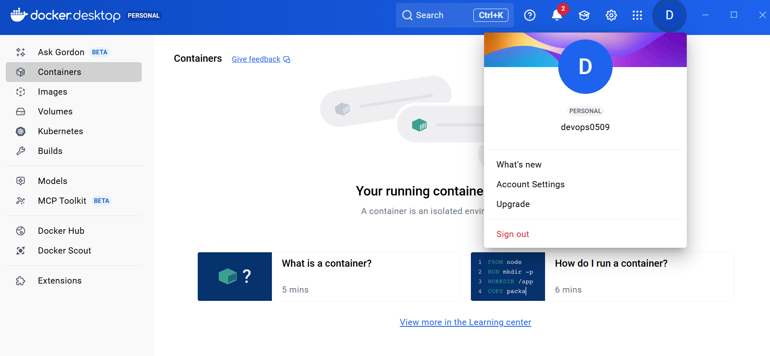

Use command- docker pull nginx:latest
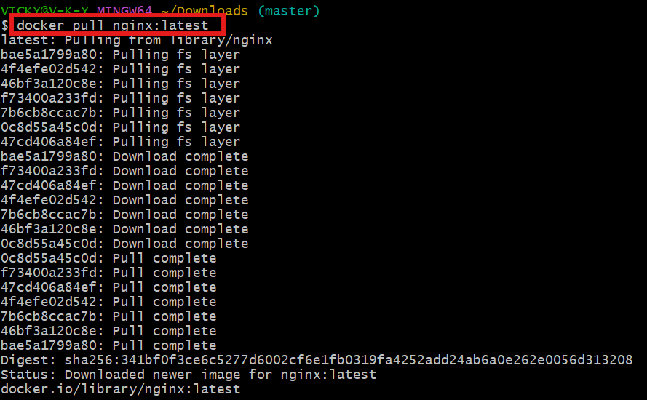

Step 2: vi index.html
<h1>Hello from Terraform Microservice 🚀</h1>
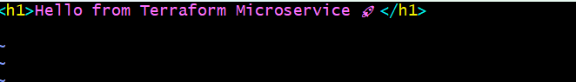

Step 3: vi Dockerfile
FROM nginx:latest
COPY index.html /usr/share/nginx/html/index.html
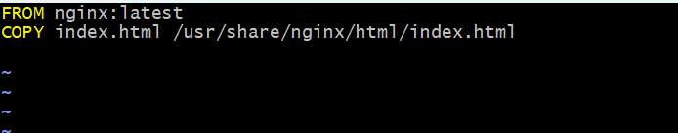
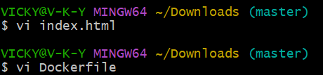

Step 4: docker build -t microservice:v1 .
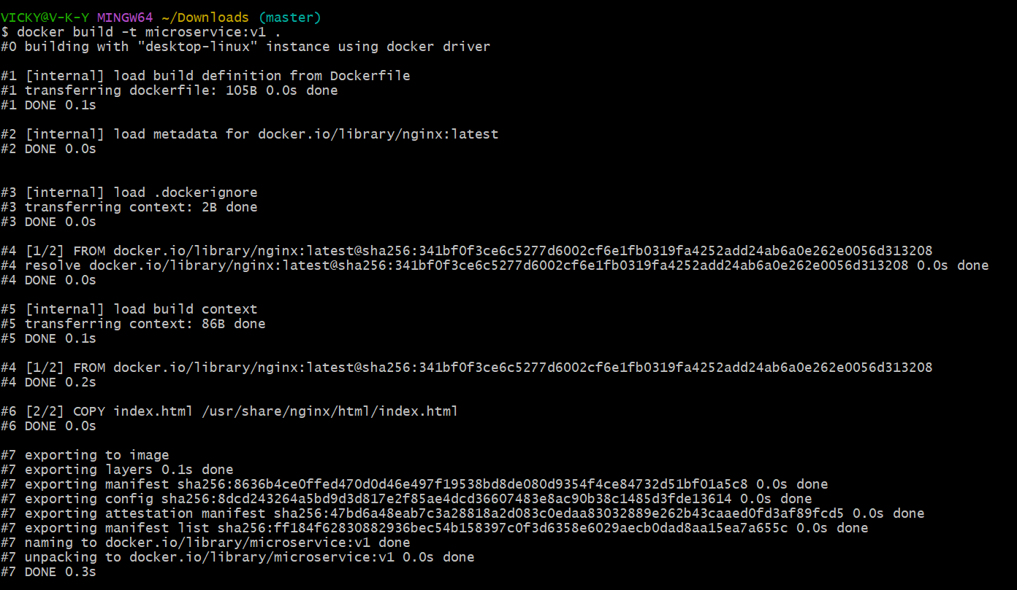
TERRAFORM PART

provider.tf
provider "aws" {
region = var.region
}
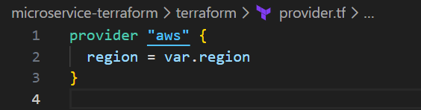

variables.tf
variable "region" {}
variable "vpc_cidr" { default = "10.0.0.0/16" }
variable "public_subnet_cidr" { default = "10.0.1.0/24" }
variable "private_subnet_cidr" { default = "10.0.2.0/24" }
variable "instance_type" { default = "t2.micro" }
variable "my_ip" {}
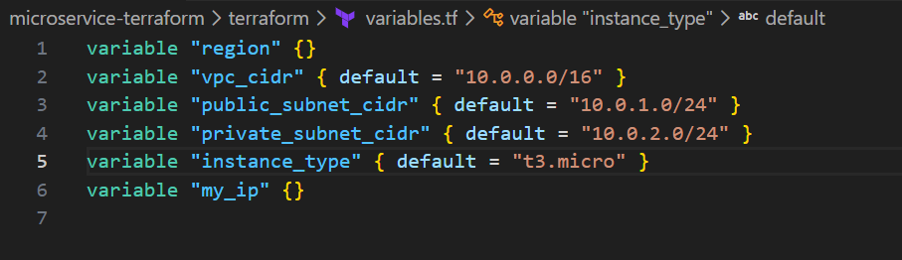

terraform.tfvars
region = "us-east-1"
my_ip = "1.2.3.4/32" # change to your IP

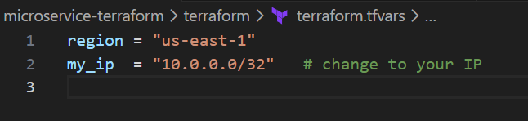

networking.tf
resource "aws_vpc" "main" {
cidr_block = var.vpc_cidr
}
resource "aws_subnet" "public" {
vpc_id = aws_vpc.main.id
cidr_block = var.public_subnet_cidr
map_public_ip_on_launch = true
}

resource "aws_subnet" "private" {
vpc_id = aws_vpc.main.id
cidr_block = var.private_subnet_cidr
}

resource "aws_internet_gateway" "gw" {
vpc_id = aws_vpc.main.id
}
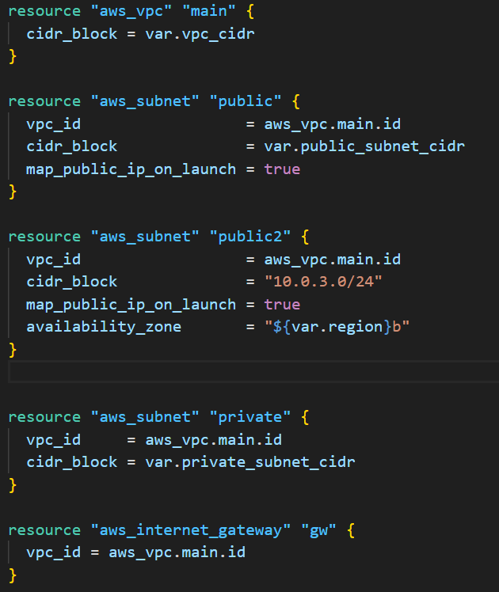

security.tf
resource "aws_security_group" "alb_sg" {
vpc_id = aws_vpc.main.id

ingress {
from_port = 80
to_port = 80
protocol = "tcp"
cidr_blocks = ["0.0.0.0/0"]
}

egress {
from_port = 0
to_port = 0
protocol = "-1"
cidr_blocks = ["0.0.0.0/0"]
}
}

resource "aws_security_group" "ec2_sg" {
vpc_id = aws_vpc.main.id

ingress {
from_port = 80
to_port = 80
protocol = "tcp"
security_groups = [aws_security_group.alb_sg.id]
}

ingress {
from_port = 22
to_port = 22
protocol = "tcp"
cidr_blocks = [var.my_ip]
}

egress {
from_port = 0
to_port = 0
protocol = "-1"
cidr_blocks = ["0.0.0.0/0"]
}
}
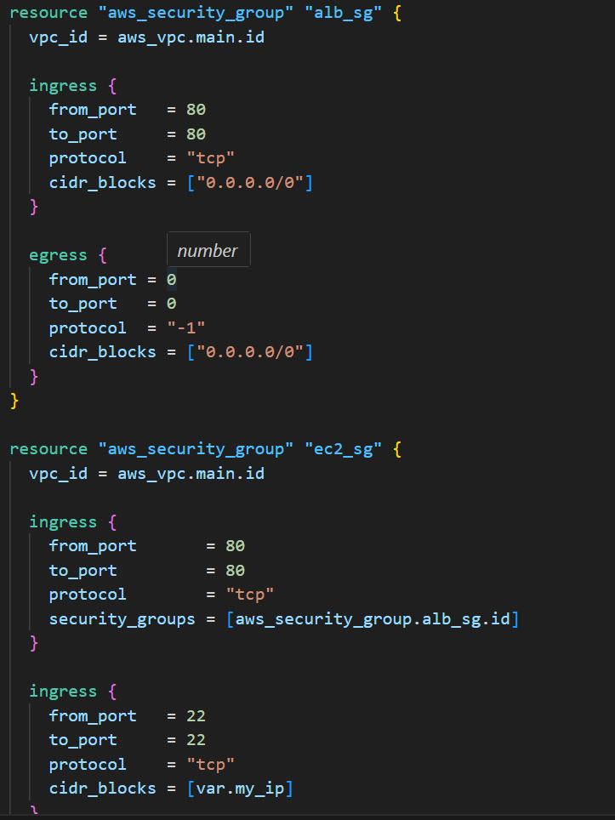

ecr.tf – Docker Registry
resource "aws_ecr_repository" "repo" {
name = "microservice"
}
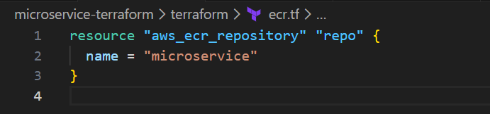

ec2.tf
data "aws_ami" "amazon" {
most_recent = true
owners = ["amazon"]

filter {
name = "name"
values = ["amzn2-ami-hvm*"]
}
}

resource "aws_instance" "vm" {
ami = data.aws_ami.amazon.id
instance_type = var.instance_type
subnet_id = aws_subnet.private.id
key_name = aws_key_pair.key.key_name
vpc_security_group_ids = [aws_security_group.ec2_sg.id]

user_data = templatefile("${path.module}/../scripts/userdata.sh", {
region = var.region
repo = aws_ecr_repository.repo.repository_url
image = "${aws_ecr_repository.repo.repository_url}:v1"
})
}

Key Pair (Local → AWS)
ssh-keygen -t rsa -f microservice

Add in terraform:
resource "aws_key_pair" "key" {
key_name = "microservice"
public_key = file("microservice.pub")
}
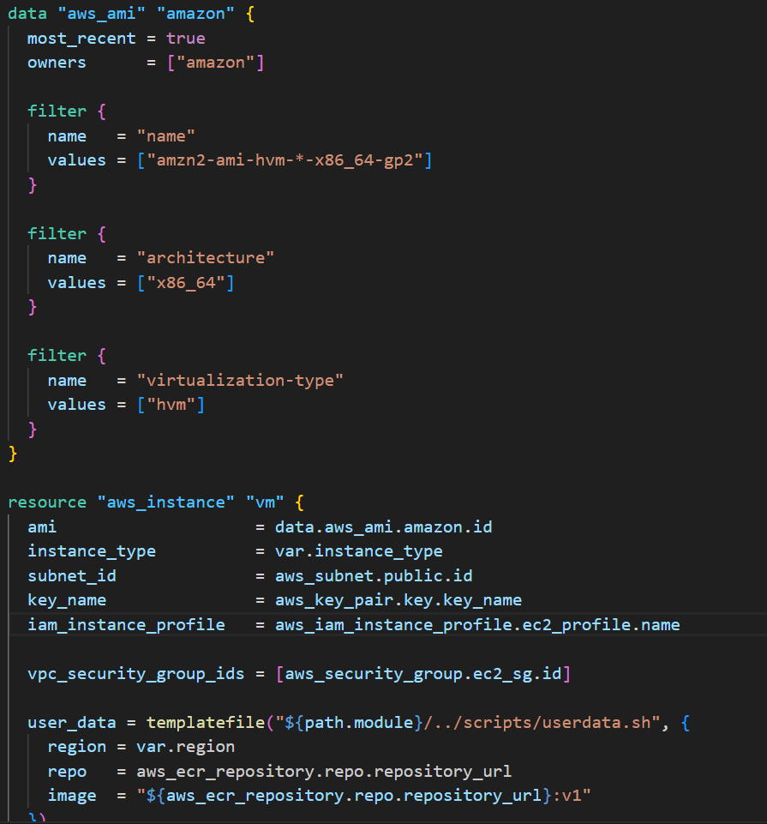

userdata.sh

This will:
✔ install docker
✔ login to ECR
✔ pull image
✔ run container

#!/bin/bash
yum update -y
yum install docker -y
service docker start

aws ecr get-login-password --region ${region} | \
docker login --username AWS --password-stdin ${repo}

docker pull ${image}
docker run -d -p 80:80 ${image}

alb.tf – Load Balancer

resource "aws_lb" "alb" {
load_balancer_type = "application"
subnets = [aws_subnet.public.id]
security_groups = [aws_security_group.alb_sg.id]
}

resource "aws_lb_target_group" "tg" {
port = 80
protocol = "HTTP"
vpc_id = aws_vpc.main.id
}

resource "aws_lb_target_group_attachment" "attach" {
target_group_arn = aws_lb_target_group.tg.arn
target_id = aws_instance.vm.id
port = 80
}

resource "aws_lb_listener" "listener" {
load_balancer_arn = aws_lb.alb.arn
port = 80
protocol = "HTTP"

default_action {
type = "forward"
target_group_arn = aws_lb_target_group.tg.arn
}
}
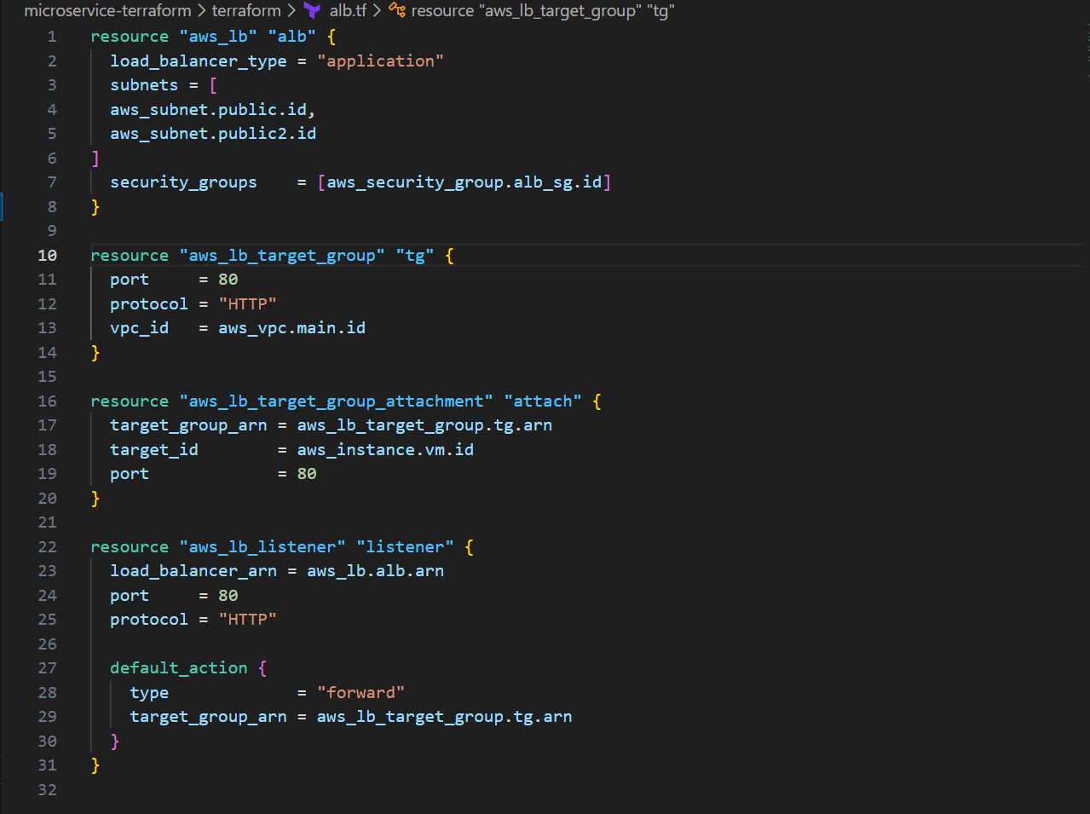

outputs.tf

output "alb_dns" {
value = aws_lb.alb.dns_name
}

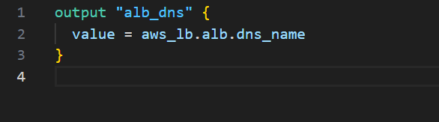

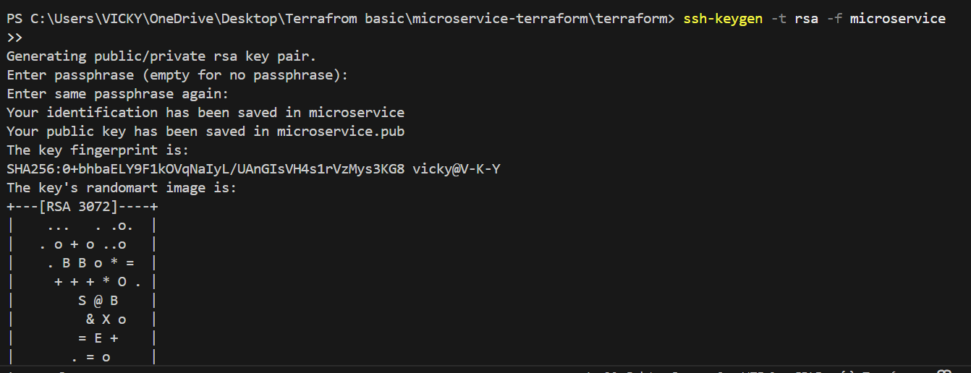

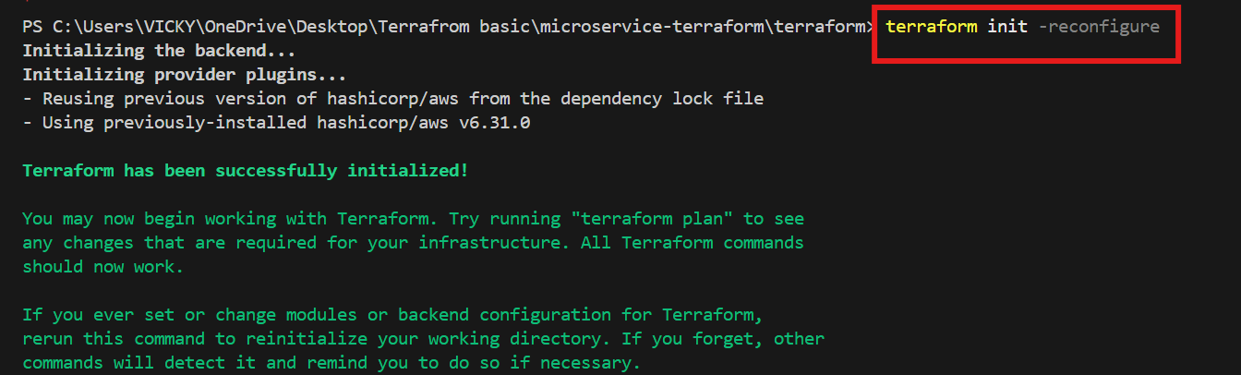

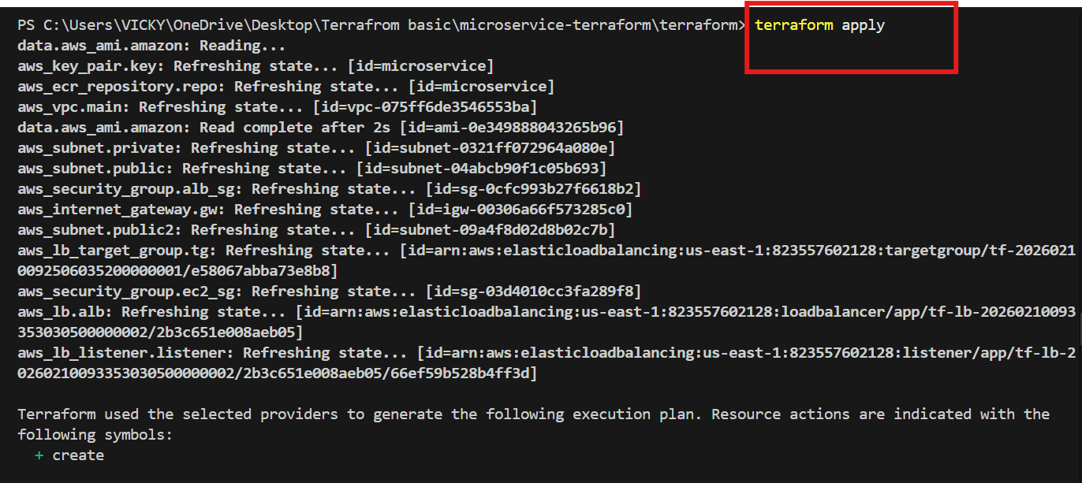

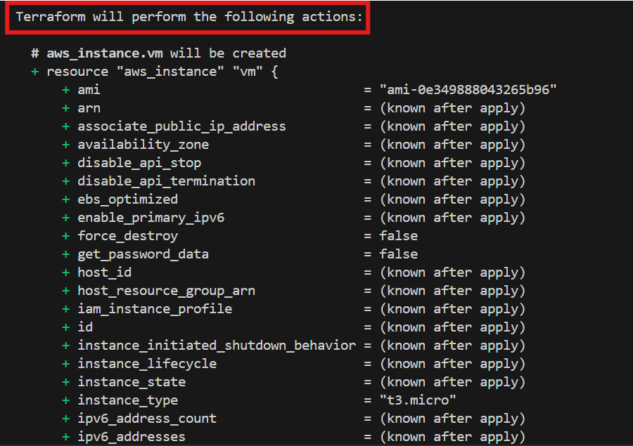

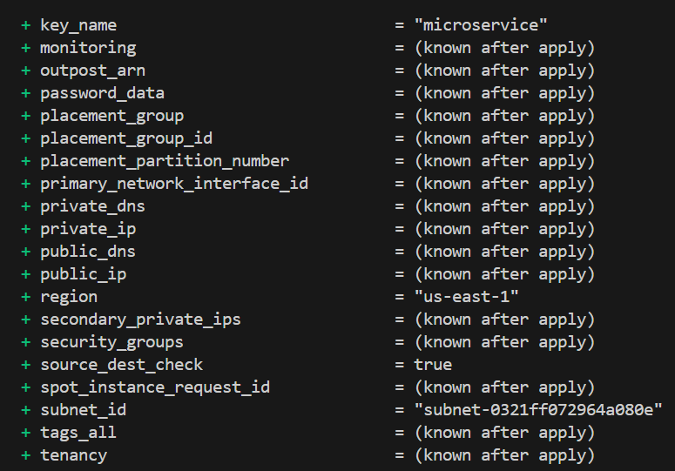

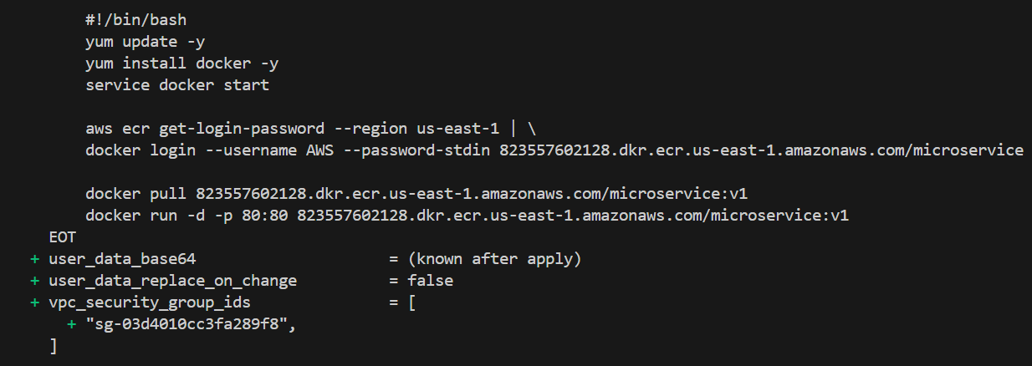

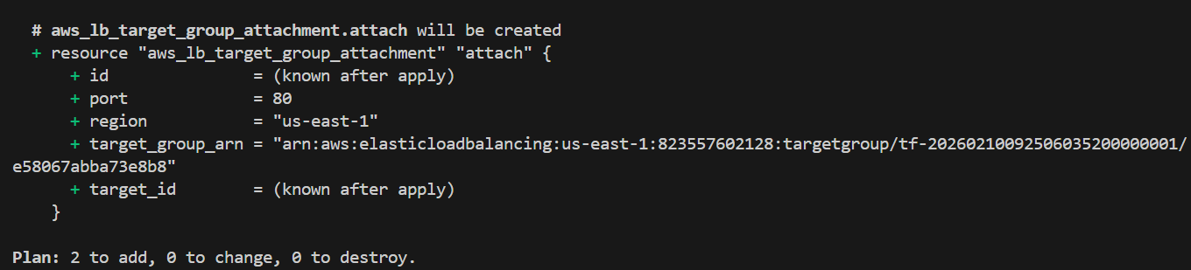

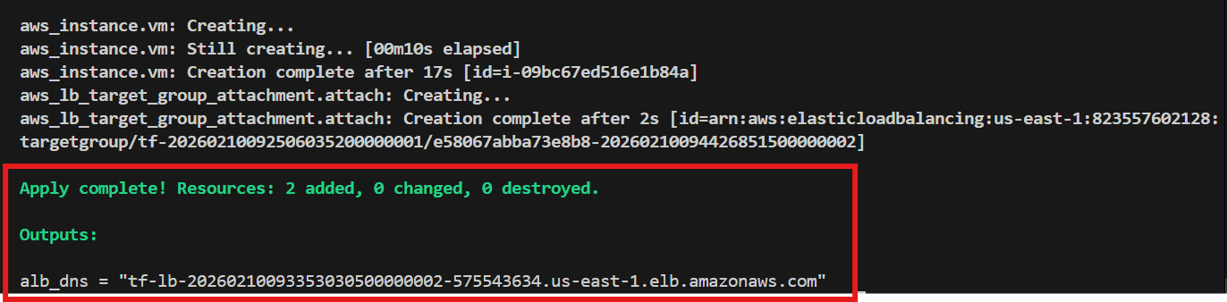
Step 3 — Terraform Push Image to ECR

Login to ECR
aws ecr get-login-password --region us-east-1 | docker login --username AWS --password-stdin 823557602128.dkr.ecr.us-east-1.amazonaws.com
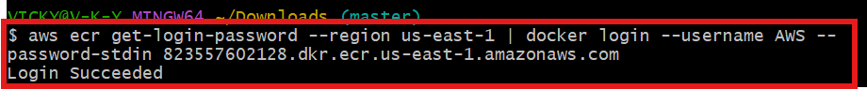
Tag
docker tag microservice:v1 823557602128.dkr.ecr.us-east-1.amazonaws.com/microservice:v1
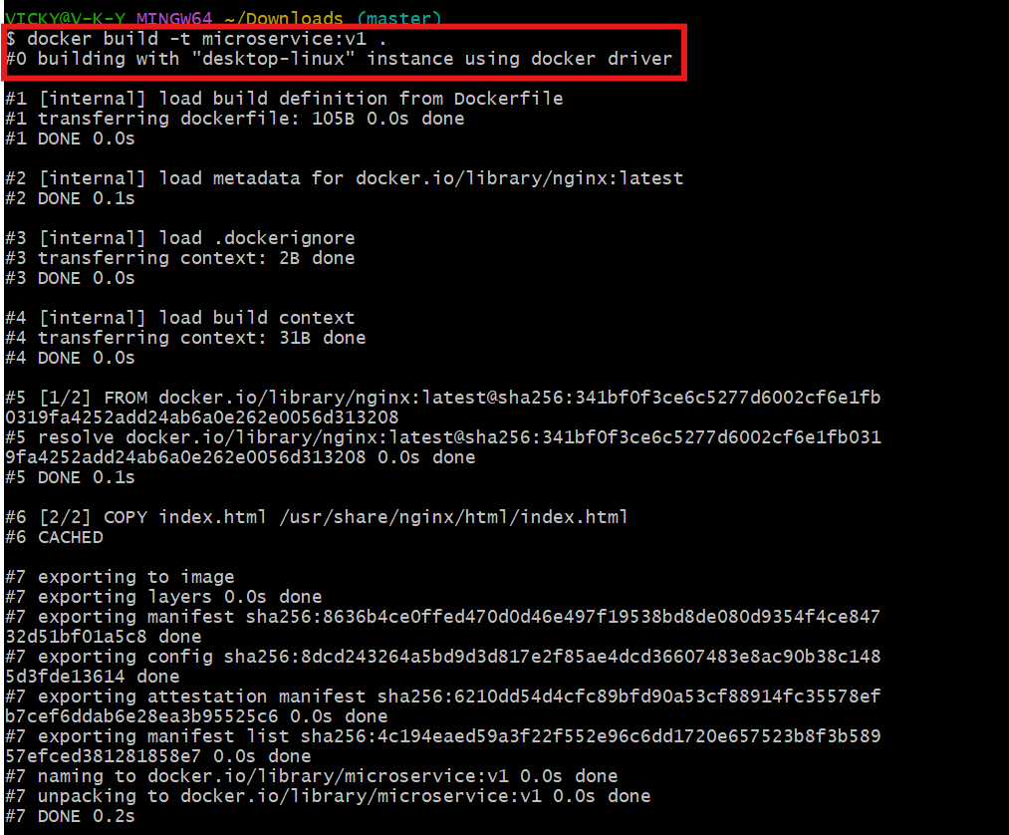

Push
docker push 823557602128.dkr.ecr.us-east-1.amazonaws.com/microservice:v1
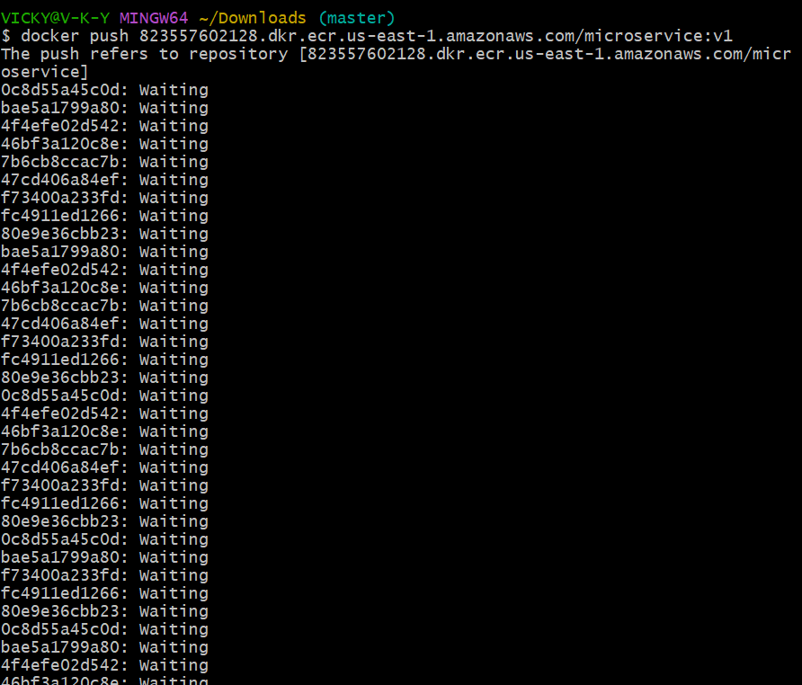
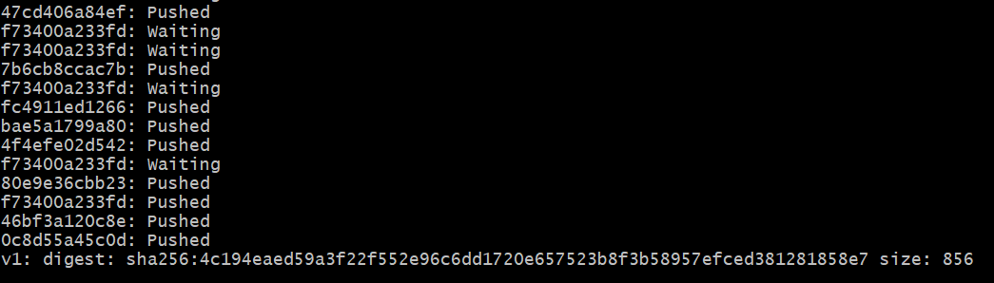
What you just did
Local Docker → AWS ECR
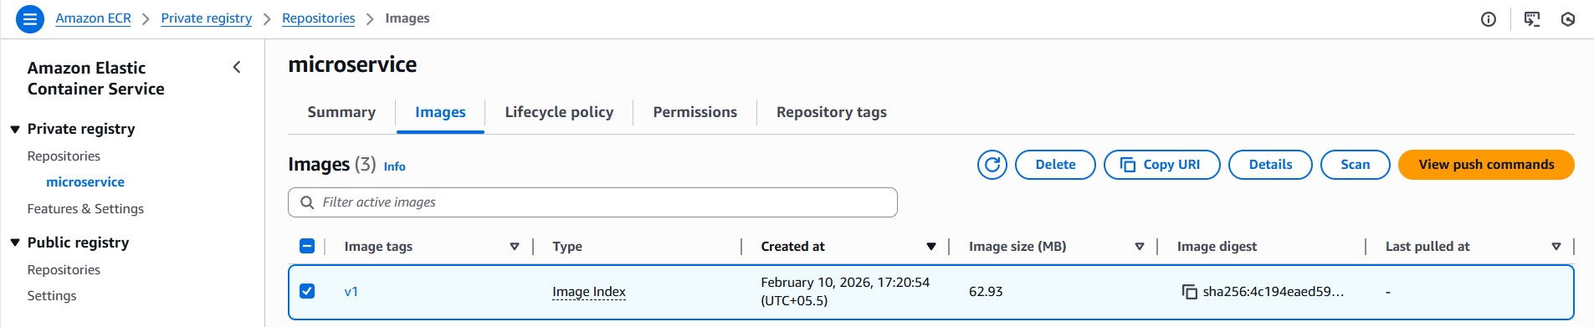

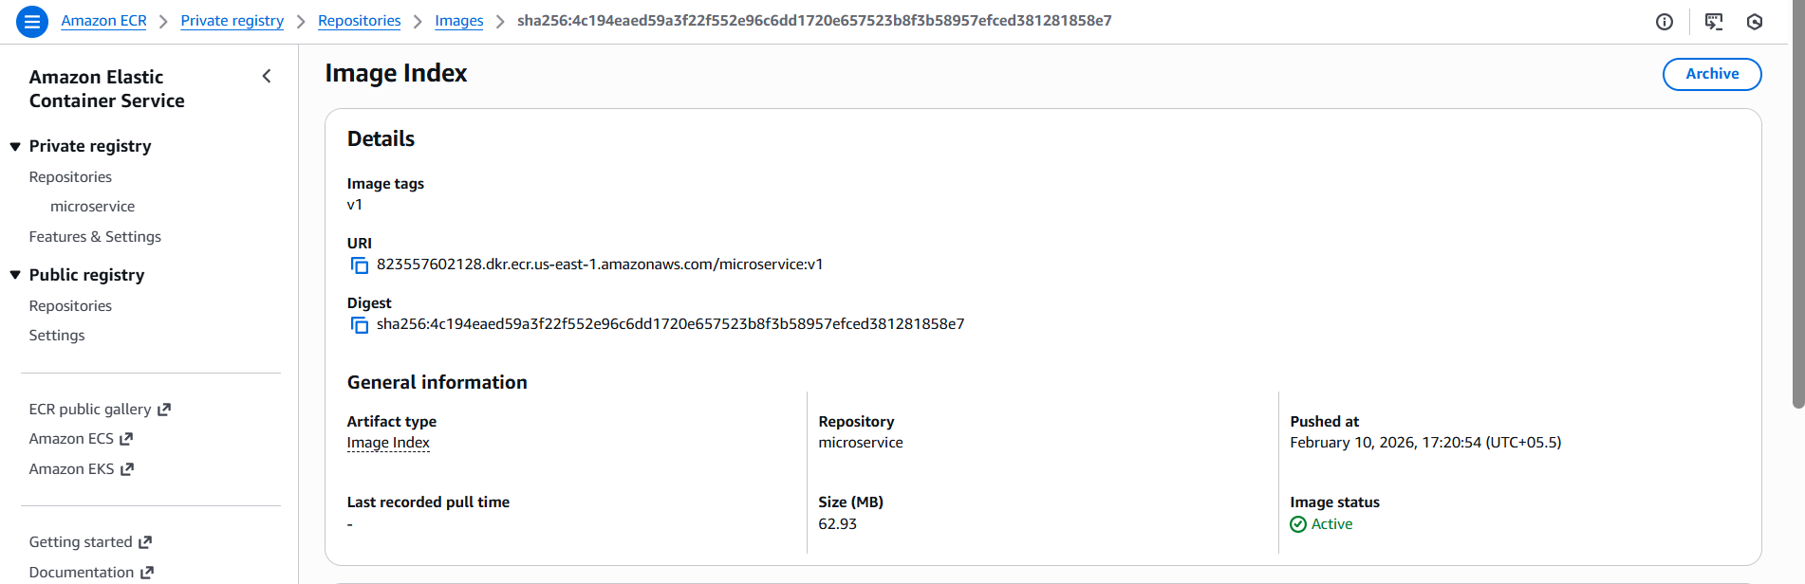

AFTER PUSH → go to EC2

docker pull 823557602128.dkr.ecr.us-east-1.amazonaws.com/microservice:v1
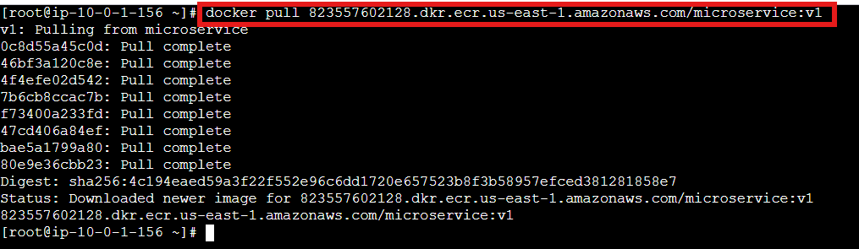

Then run container:
docker run -d -p 80:80 823557602128.dkr.ecr.us-east-1.amazonaws.com/microservice:v1

Then test Load Balancer
Success- Automation worked successfully
Conclusion
We successfully designed and deployed a secure, automated microservice platform where:
- Application is containerized
- Image is centrally stored
- Infrastructure is reproducible
- VM is protected
- Service is reachable only through Load Balancer
- Manual intervention is eliminated

